**3)Lesson Title: Hybridization**

**Lesson Topic: Identity**

**Introduction:**

Students will continue their use of symbolic meaning and will identify and list key characteristics that define their identity or who they are. Students will go further in depth with their studies of Identity and will begin researching symbolic meaning of different animals. Students will further their practice and will combine creatures into one hybrid form that represents them.

**Standards:**

1.1 Visualize and hypothesize to generate plans for ideas and directions for creating art and design that can affect social change

1.2 Choose from a range of materials and methods of traditional and contemporary artistic practices, following or breaking established conventions, to plan the making of multiple works of art and design based on a theme, idea, or concept.

2.1 Experiment, plan, and make multiple works of art and design that explore a personally meaningful theme, idea, or concept.

2.2 Demonstrate understanding of the importance of balancing freedom and responsibility in the use of images, materials, tools, and equipment in the creation and circulation of creative work.

4 Critique, justify, and present choices in the process of analyzing, selecting, curating, and presenting artwork for a specific exhibit or event.

8 Analyze differing interpretations of an artwork or collection of works in order to select and defend a plausible critical analysis.

9 Construct evaluations of a work of art or collection of works based on differing sets of criteria

10 Synthesize knowledge of social, cultural, historical, and personal life with art-making approaches to create meaningful works of art or design

**Vocabulary:**

* Hybridization
* Proportion
* Unity
* Pattern
* Texture
* Composition

**Objectives/Big Ideas**

*Students/community members will…*

Know/Understand:

* Students will understand the term symbolism and how it impacts the meaning of an artwork and how symbolism can be a tool in self representation. \
* Students will understand how to make artistic decisions in order to connect projects personally

Be Able to Do:

*What skills and habits of mind will this lesson help develop?*

* Use the elements and principles of design to develop works of art
* Choose specific animals that relate to personal characteristics using symbolism
* Discuss their intent with a final project and answer reflection questions.

**Essential Question**

 How can you use qualities of animals to create a creature that represents who you are?

**Sub-essential Questions**

* What makes you who you are? What are things that define you?
* What makes an animal unique? When we see a zebra, what is the first thing we notice about it?
* What animals best represent the characteristics that you have chosen to define you?
* What specific parts of these animals do you want to use (ex. Feet, color/pattern, wings, claws etc.)
* What parts from each animal do you find the most interesting? Do certain anatomy parts of animals have symbolic meaning? (ex. Rabbit’s Foot)
* What part from each animal are you going to use in your combined drawing? Why?

**Materials Needed:**

* Sketchbook
* Material of choice
* Computer
* Camera/phone

**Activities/Procedures:**

1. warm up activity. Question on symbolism of animals
2. Video from the Golden Compass on animal representation
3. Intro to the topic of Hybridization with images and student work examples
4. Essential question and discussion
5. Students’ complete identity worksheet and choose minimum of three main qualities/characteristics to work with
6. Students’ complete mini sketches in workbook and brainstorm animals that represent each characteristic
7. Student brainstorm how to combine at least three and choose what material to work with for the final project
8. Begin final artwork
9. Reflection page, rubric, and walk around critique with sticky notes for peer feedback

**Assessment/Evaluation**

*How will I know what students have learned?*

* Collect the identity worksheets to check for understanding by making sure that students have followed directions and have made lists of animals for each characteristic. Students will be assessed on completion.
* Warm up/exit ticket questions
* Reflection page and rubric

Name:

Identity

What makes you the person you are? What are things that define you? Make a list of 6 characteristics that you feel best represent you are and explain why.



**Reflect**:

Do you feel that the characteristics you have identified and described are the best to represent you? Are there other characteristics not listed that you might want to explore? How are these characteristics important to you?

**Next Steps:**

In your workbook, make lists of animals that represent/symbolize each of the listed qualities.

**Examples of Good Qualities/ Characteristics**

* Intelligent
* Extravagant
* Dependable
* Honest
* Friendly
* Eccentric
* Kind
* Happy
* Trustful
* Likeable
* Patient
* Courageous
* Creative
* Generous
* Energetic
* Independent
* Adventurous
* Curious
* Charming
* Tidy
* Practical
* Humble
* Decisive
* Studious
* Outgoing
* Hopeful
* Artistic
* Athletic
* Funny
* Sentimental
* Lucky
* Persistent
* Bold
* Shy
* Ambitious
* Helpful
* Consistent

Name:

Reflection

1. What three characteristics did you choose to represent you?

Characteristic 1:

Characteristic 2:

Characteristic 3:

1. What animals did you choose to draw? How do these animals represent your characteristics listed above? Explain

Animal 1:

Animal 2:

Animal 3:

1. What kind of habitat is your hybrid in (ocean/forest/sky etc.)? Why did you choose to draw this for your background?

1. What colors did you choose for your hybrid and your background? Did you choose natural colors or are there other colors added that you wouldn’t normally see in nature? What meaning do your colors add (Think about the meaning of warm/cool colors)?

1. Are there any additional details that you added to your drawing that are notable or special?

Name:

**Hybridization Rubric**

|  |  |  |  |  |
| --- | --- | --- | --- | --- |
| Points | **Excellent**  **10-9** | **Good**  **8-7** | **Proficient**  **6-5** | **Emerging**  **4-0** |
| **Hybridization/Symbolism** | At least 3 animals are combined and are clearly identifiable. Choices of animals show clear connection to personal characteristics and identity. Outstanding use of symbolism. | Three animals are illustrated. Good use of symbolic meaning and connects to identity. | Only two animals are combined. Little to no symbolic meaning is illustrated. Connection to identity is not clear. | No connection between choice of animals and personal qualities. Symbolism is not utilized. |
| **Composition/Background** | Background illustrates realistic habitat. Adds to overall meaning and relates to hybrid creature | Habitat is created thoughtfully. Adds to meaning of the work. Could show more detail. | Habitat is illustrated but shows very little detail. Could use more work | Background does not relate to hybrid. Is not relevant to meaning of the work |
| **Color Theory** | Color was carefully chosen and references to color theory are clear. (thought about warm/cool colors) Successfully adds meaning to the final work | Chose color appropriately. Adds to meaning but could be more developed | Color is illustrated. Minimal reference to theory. Did not think about warm vs cool color implications | Color was chosen randomly. Does not relate to theory or meaning of the work |
| **Value** | Value is implemented and is blended successfully. Creates depth in the drawing. Shading and highlights are clearly visible | Value is clear, and transitions are proficiently demonstrated. Good shading practice is shown | Minimal amount of value was added. Could use more shading to add dimension | Did not create value. Drawing appears flat or 2-dimensional |
| **Creativity/Originality** | Explored several choices before selecting final choice. Generated many ideas, tried unusual combinations or changes, used problem-solving skills. | Tried a few ideas before selecting one or based work on someone else’s idea, made decision after referring to one source. Could have brainstormed more | Fulfilled the requirements of the assignment and tried an idea, but it lacked originality, might have copied work. Did not think about symbolism or identity. | Gave no evidence of trying anything unusual. Student did not think conceptually |
| **Effort/Time Management** | The project was completed, and extensive effort was put into it. Used class time wisely. Student challenged themselves | Completed the project and used class time proficiently. Decent amount of effort was shown | Finished the project, but it could have been improved with more effort, chose an easy project and was not challenging | Project was not completed or finished with minimal effort |

Total: /60

Teacher Comments:

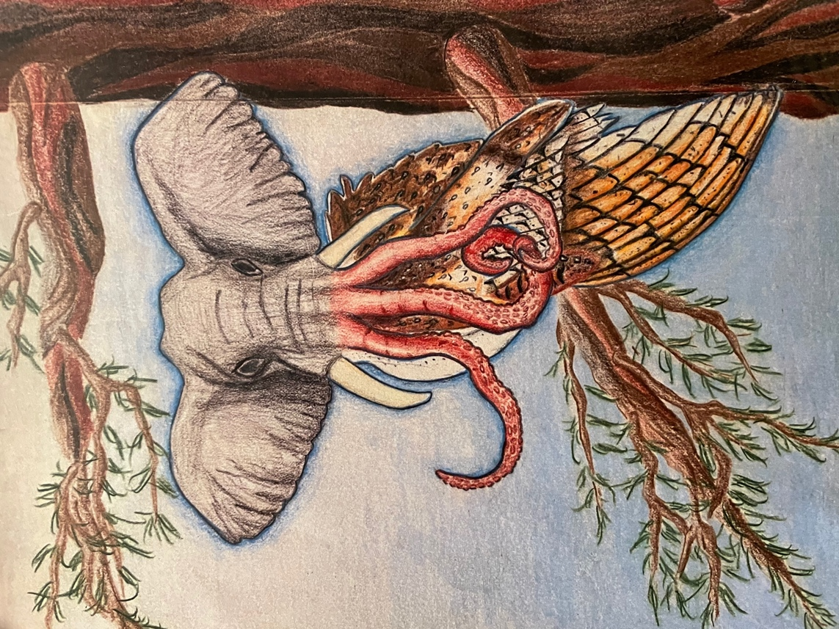Examples

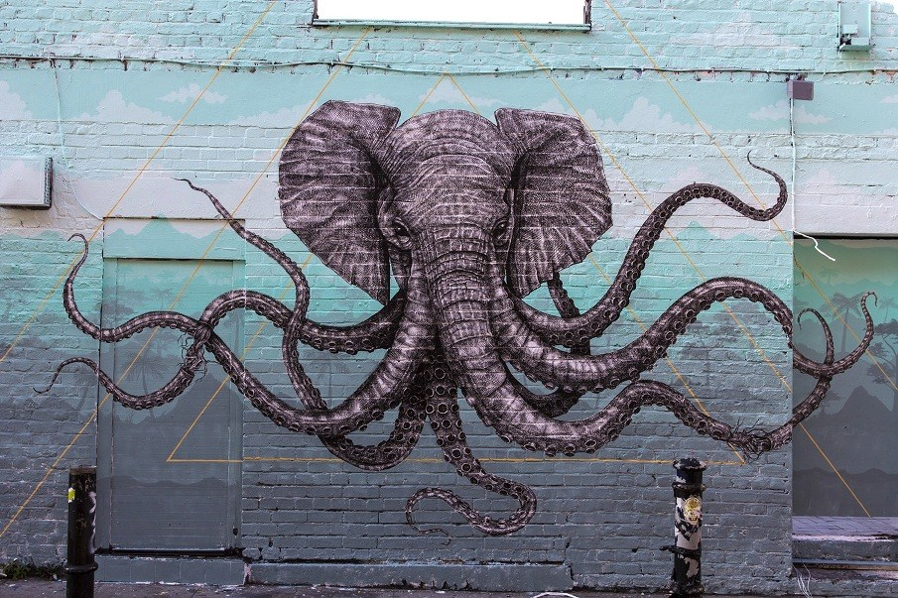Non-Examples