2)Lesson Title: Still Life
Lesson Topic: Identity

Introduction:
Students will create a still life artwork that depicts personal objects. Students must choose a minimum of five objects to bring from home that represent who they are in a context that is relevant, meaningful, and unique. Students will choose appropriate materials to successfully create a work that relates to them using the elements and principles of design and other artistic strategies

Standards:
1.1 Visualize and hypothesize to generate plans for ideas and directions for creating art and design that can affect social change

1.2 Choose from a range of materials and methods of traditional and contemporary artistic practices, following or breaking established conventions, to plan the making of multiple works of art and design based on a theme, idea, or concept.

2.1 Experiment, plan, and make multiple works of art and design that explore a personally meaningful theme, idea, or concept.

4 Critique, justify, and present choices in the process of analyzing, selecting, curating, and presenting artwork for a specific exhibit or event.

6 Curate a collection of objects, artifacts, or artwork to impact the viewer’s understanding of social, cultural, and/or political experiences

7.1 Analyze how responses to art develop over time based on knowledge of and experience with art and life

10 Synthesize knowledge of social, cultural, historical, and personal life with art-making approaches to create meaningful works of art or design

11 Appraise the impact of an artist or a group of artists on the beliefs, values, and behaviors of a society

Vocabulary:
- Composition
- Space
- Proportion
- Form
- Unity

Objectives/Big Ideas
Students/community members will…
Know/Understand:
- The meaning/impact of symbolism and how it can be used as a mode of communication and self-representation.
- How placement and scale of objects alter the intent or meaning of the work overall
- How other elements and principles of design impact the work overall

Be Able to Do:
What skills and habits of mind will this lesson help develop?
- Choose objects carefully and with intent regarding symbolic meaning.
- Make decisions with art material to best express their still life artwork and its message.

Essential Question
How can you create meaning and depict a story from personal items?

Sub-essential Questions
- What are key factors of your identity? What makes you you?
- How might these parts of you be represented?
- What personal items did you choose and why?
- How do these objects relate to you?
- How did you choose to arrange your objects? Does the arrangement add any significance to the meaning of your objects?

Materials Needed:
- Sketchbook
- Personal object (5 minimum)
- Material of choice
- Computer
- camera/phone

Activities/Procedures:
- Warm up activity and project Introduction with personal example, images of things that represent my personal identity and how we will make a still life made up of these objects
- Slideshow of examples showing students images with symbolic meaning
- Discuss with students that they will need to bring objects that represent them. Depending on the object they can leave them in class or will bring them back and forth to school with them. They can also take photographs of their objects if necessary.
- Display guiding questions to be answered in workbooks and brainstorm 5 objects they want to bring to draw for their “self-portrait” set up
- Mini sketches and practice still life set up in classroom
- Students will bring in items and brainstorm arrangements. Take a photo of the set up once chosen, for reference.
- Choose medium and materials and begin final project
- Full class critique and assessment rubric/reflection page

Assessment/Evaluation
How will I know what students have learned?
- Warmups and Exit tickets throughout course of the project to check for understanding/progress
- Reflection page with questions regarding vocabulary and Understanding goals. Reflection sheet is also good to understand the students process and artistic choices
- Self-assessment rubric which allows the student to visually analyze their work and make sure they hit all of the requirements
- Critique. Constructive Feedback from peers

Name:
Reflection

- What personal items did you choose and why?

- How do these items connect to you culturally/socially/personally?

- How did you choose to arrange your objects? Does the composition add any significance to the meaning of your objects?

- How did you utilize proportion? Are objects skewed or accurate representations? Why?

- How did you utilize color in your work? (Warm/cool/complimentary/analogous etc.) If you did not, how does the lack of color impact your work?

- Are there any additional details that you added to your drawing that are notable or special?

Name:
Self-Assessment Rubric: Still Life
 | Excellent  10-9 | Good  8-7 | Proficient  6-5 | Emerging  4-0
Design | Student chose medium carefully, and really thought of how the material would add to the work. | Material was chosen. Applied successfully | Chose a material but did not think about how it would affect the meaning | Material chosen carelessly.
Personal Connection | Objects chosen clearly hold personal significance. The objects play well together in telling a story about the artist | Objects chosen connect to the artist. There is variance between them. At least 5 are depicted | 5 objects are chosen. Could relate to the artist more | Student did not choose objects carefully. Minimal connection is visible. Less than 5 depicted
Color | Color was carefully chosen and references to color theory are clear. (thought about warm/cool colors) Successfully adds meaning to the final work. Lack of color also influences the meaning | Chose color appropriately. Adds to meaning but could be more developed | Color/b&w is illustrated. Minimal reference to theory/value. Did not think about implications | Color was chosen randomly. Does not relate to theory or meaning of the work
Space/Composition | Utilizes positive and negative space. Creates depth within the work. Arrangement of objects influences the work and adds to the meaning. Draws your eye around the entire work | Space is implemented. Creates depth in the work and keeps the viewers’ attention | Demonstrates understanding of space but could be developed further | Work is flat. Development of pace was not utilized
Effort | The project was completed, and extensive effort was put into it. Used class time wisely. Student challenged themselves | Completed the project and used class time proficiently. Decent amount of effort was shown | Finished the project, but it could have been improved with more effort, chose an easy project and was not challenging | Project was not completed or finished with minimal effort. Student was off task
Total: /50

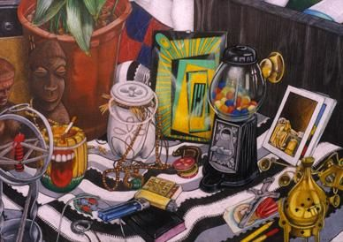
Examples
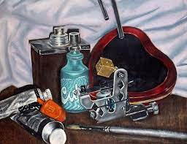
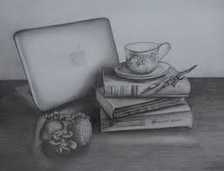
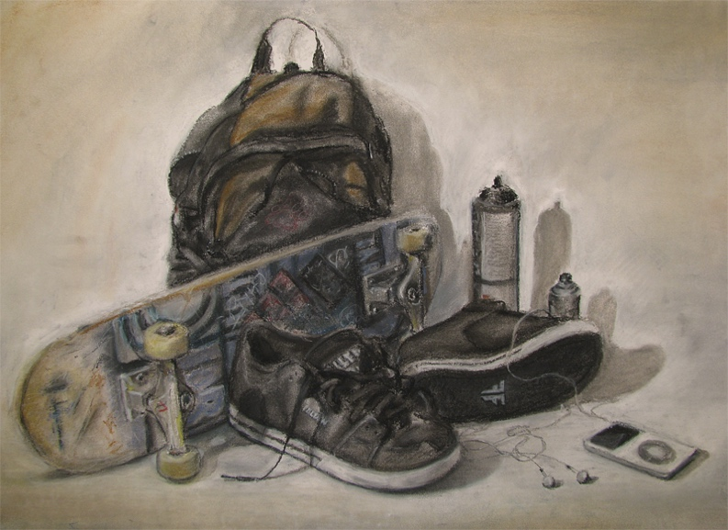
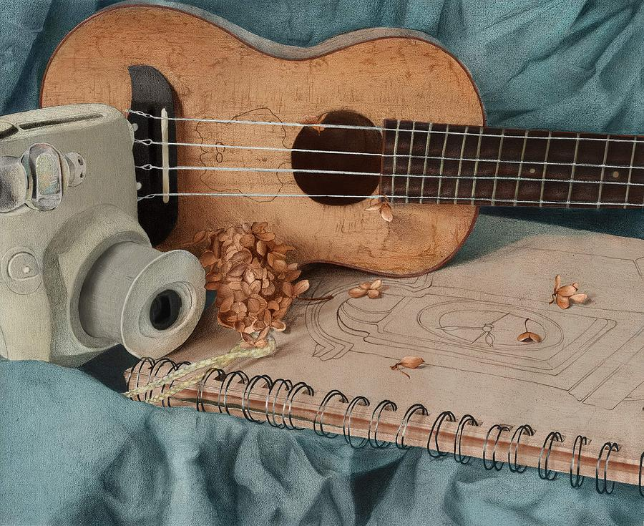
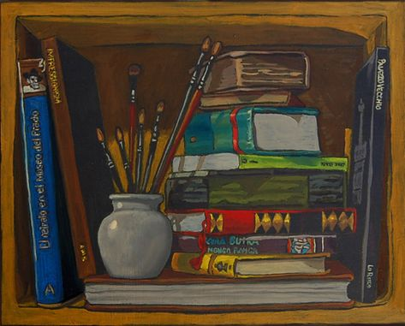
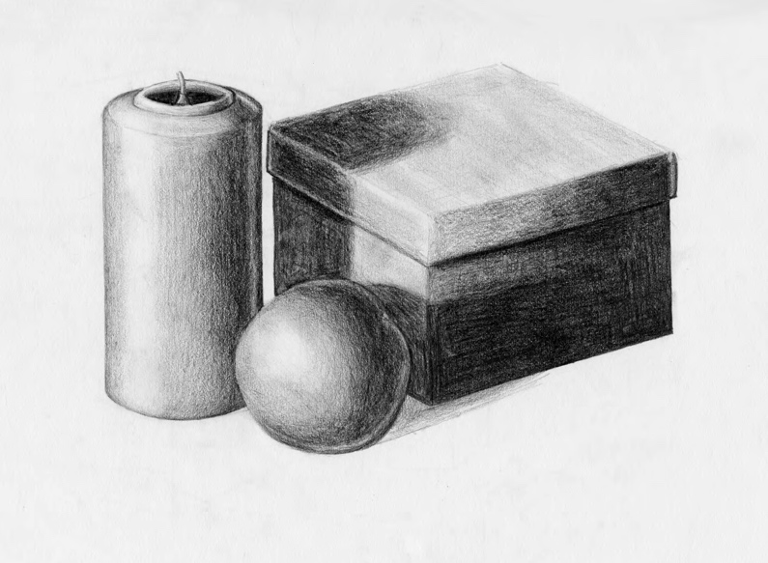
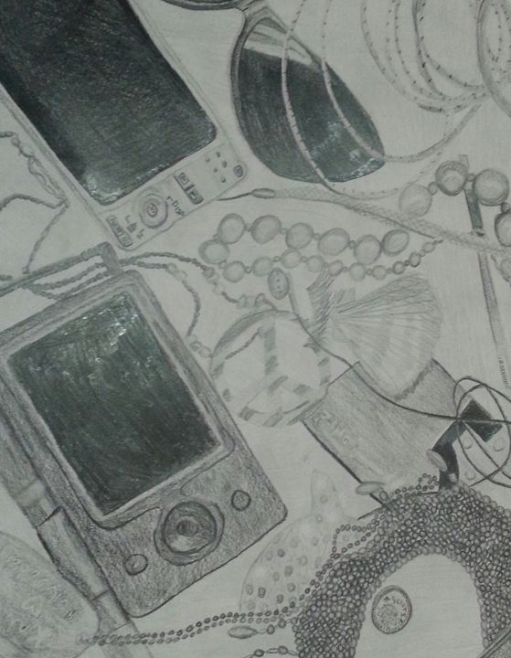
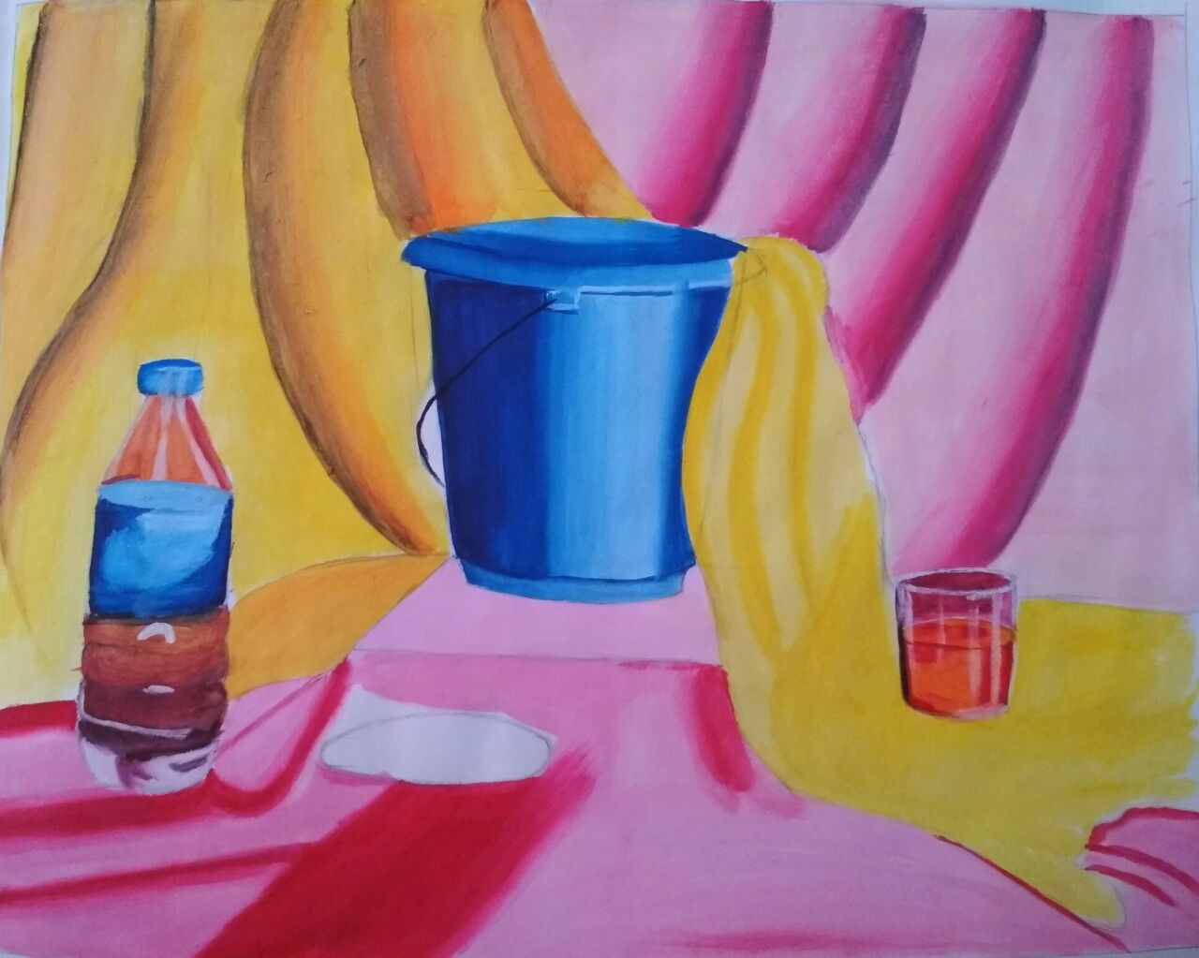
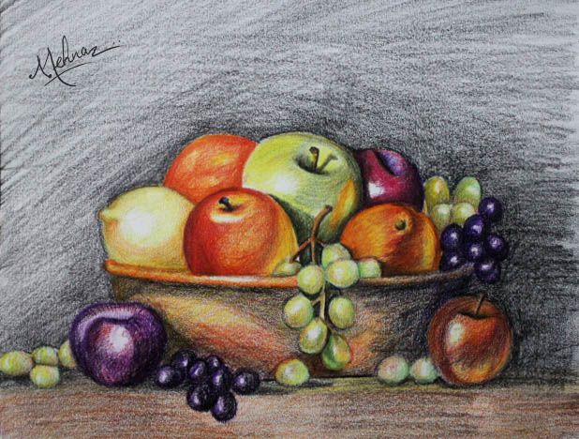
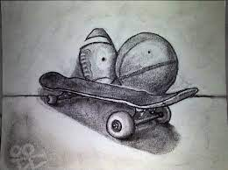
Nonexamples

